**2. Spring Rest HandsOn**

**Exercise – 1 : Hello World RESTful Web Service**

* **pom.xml**

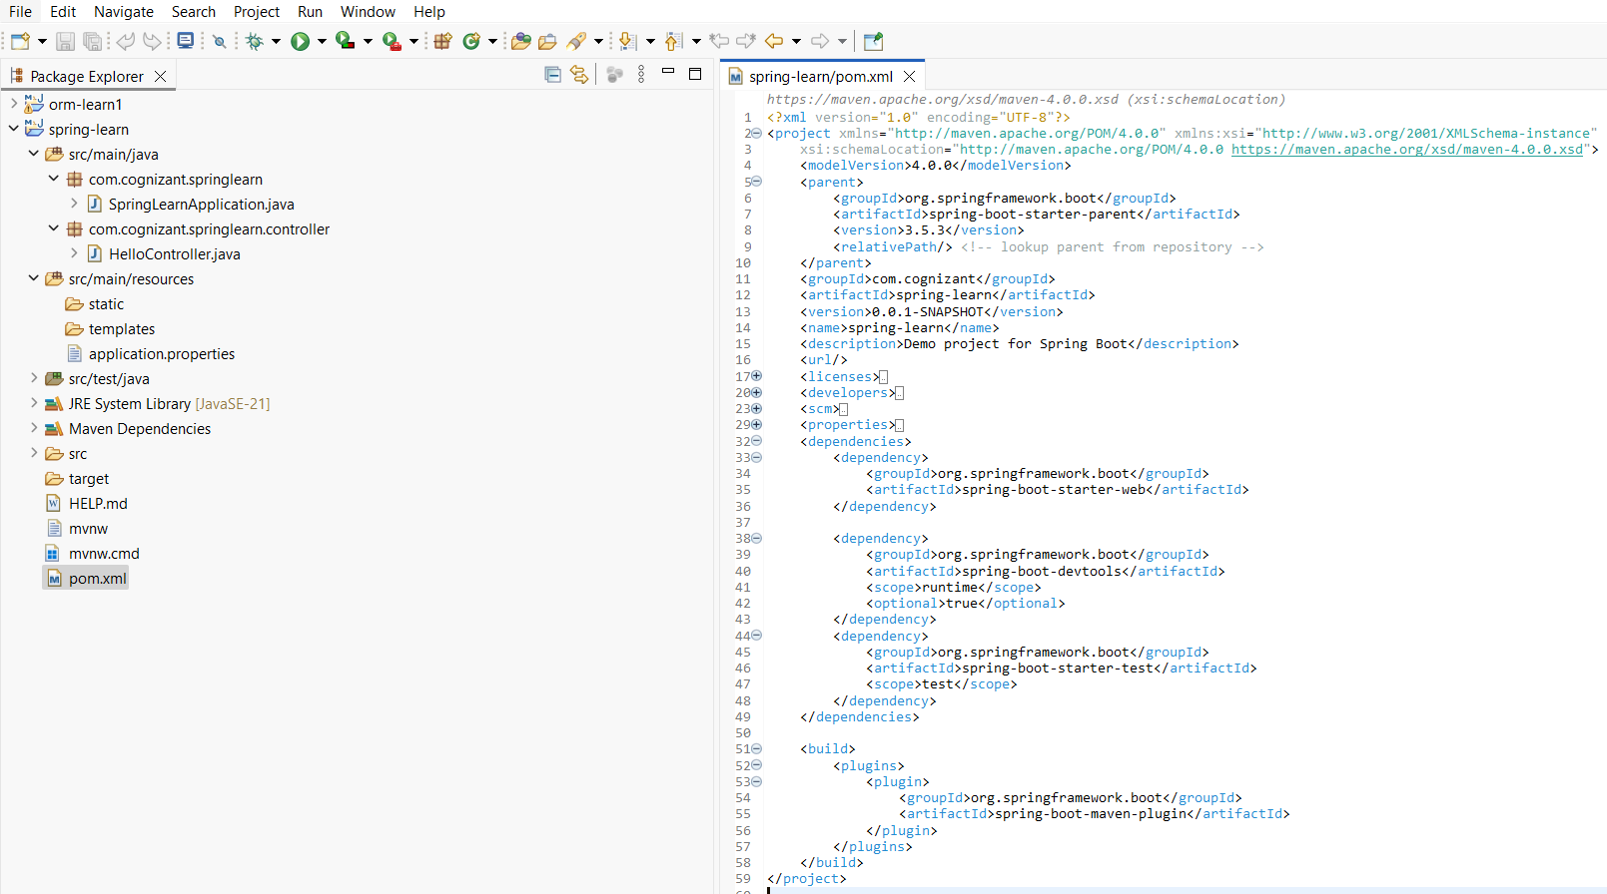

* **com.cognizant.springlearn.controller – HelloController.java**

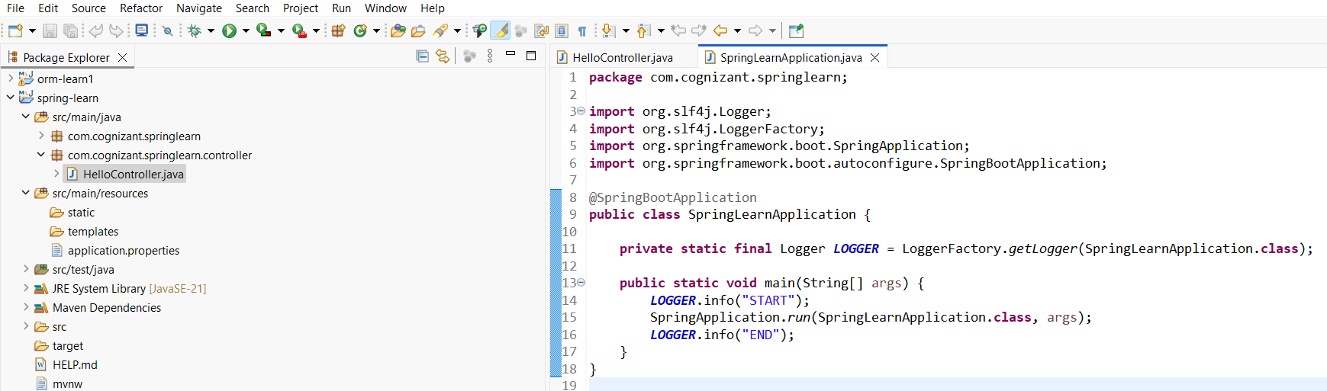

* **application.properties**

* **com.cognizant.springlearn – SpringLearnApplication.java**

* **Console Output**

* **Link after running java application -** [**http://localhost:8083/hello**](http://localhost:8083/hello)

**Exercise - 2: REST - Country Web Service**

* **pom.xml**

* **application.properties**

* **country.xml**

* **com.cognizant.springlearn – Country.java**

* **com.cognizant.springlearn – SpringLearnApplication.java**

* **com.cognizant.springlearn.controller – CountryController.java**

* **Console Output**

* **Localhost Link -** [**http://localhost:8083/country**](http://localhost:8083/country)

**Exercise – 3: REST - Get country based on country code**

* **pom.xml**

* **country.xml**

* **application.properties**

* **com.cognizant.springlearn – Country.java**

* **com.cognizant.springlearn.controller – CountryController.java**

* **com.cognizant.springlearn.service – CountryService.java**

* **com.cognizant.springlearn.service.exception – CountryNotFoundException.java**

* **com.cognizant.springlearn – SpringLearnApplication.java**

* **Console Output**

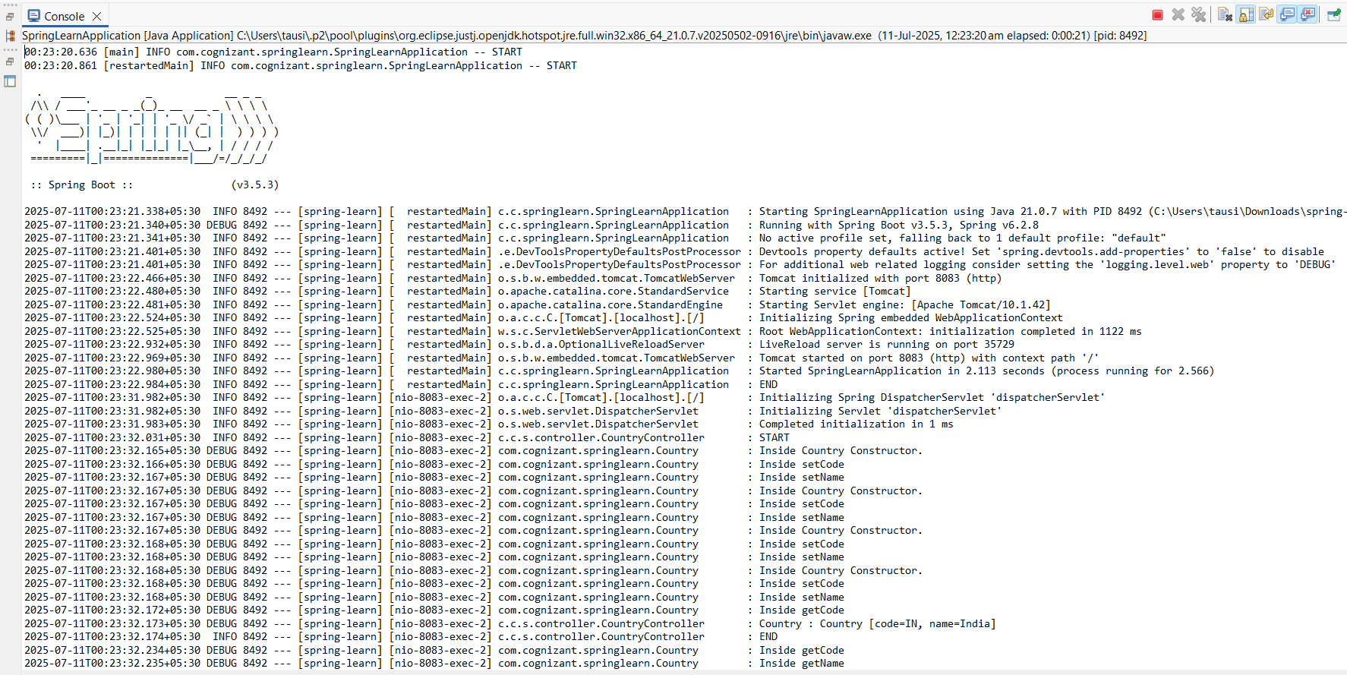

* **Localhost Link -** [**http://localhost:8083/countries/in**](http://localhost:8083/countries/in)

